Wikidata Concepts Monitor (WDCM) Design

The WDCM prototype, which can give a glimpse on what will the final product be like, is here: http://wdcm.wmflabs.org/WDCM_Dashboard/ - the prototype is built from data on 20 large projects. The real thing will have to work with hundreds (approx. 800) projects, namely all projects that have client-side Wikidata usage tracking enabled (in effect: they have the wbc_entity_usage table in the respective database in the MariaDB m2 replica).

Essentially, the project aims to develop a set of Shiny Dashboards that will provide Wikidata Usage Analytics, which means: various statistical overviews, models, and analyses in relation to how Wikidata are used across the sister projects.

The following figure represents the current WDCM workflow:

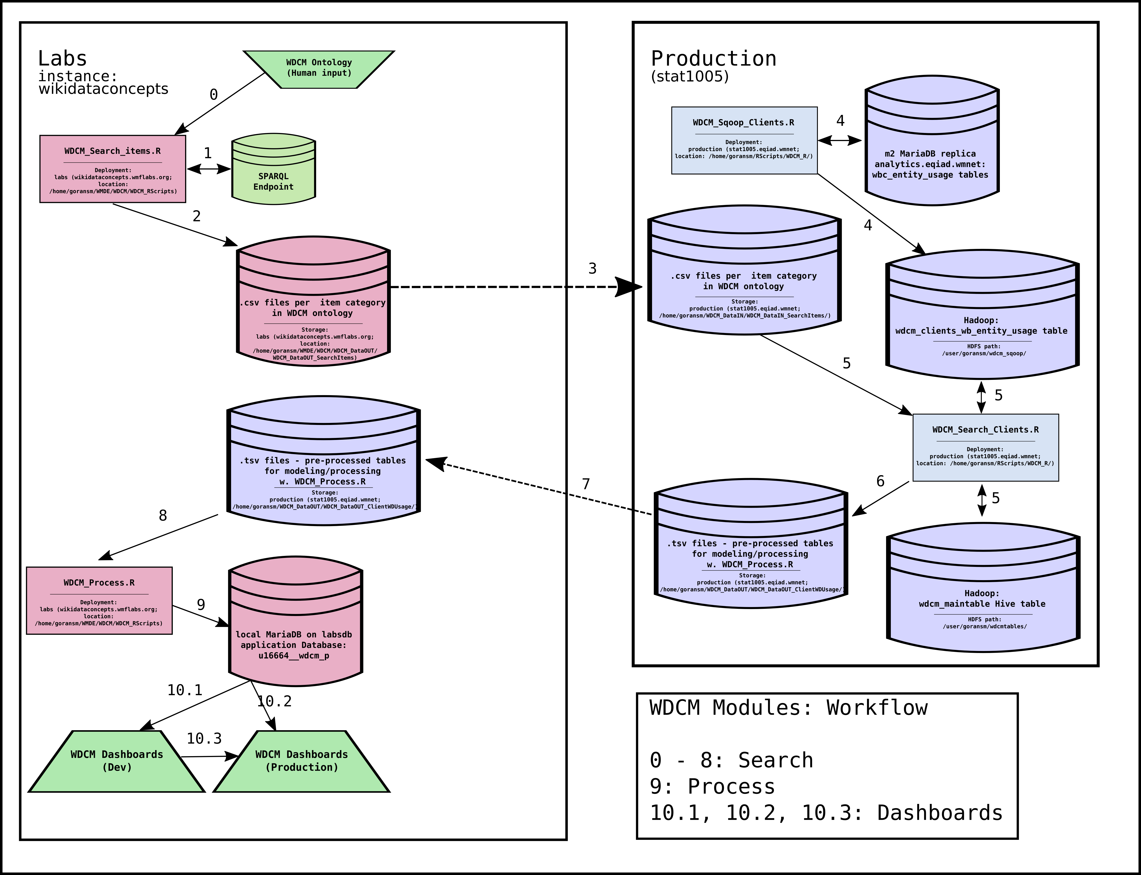

Let’s explain the workflow in a narrative:

[NOTE]: Labs = wikidataconcepts instance; Production = stat1005

0. The WDCM Ontology – a set of semantic categories, each defined by a unique SPARQL query is defined;
1. The WDCM_Search_Items.R script runs a set of SPARQL queries from Labs against the Wikidata SPARQL endpoint to collect all item IDs from all semantic categories of the WDCM_Ontology from Wikidata;
2. The WDCM_Search_Items.R script produces a .csv file per semantic category; each .csv file is a list of item IDs (e.g. Q5, Q100, etc)
3. These files migrate to Production;
4. WDCM_Sqoop_Clients.R is run to collect the update wbc_entitiy_usage tables (MariaDB m2 replica) from all clients that have Wikidata client-side usage tracking; the script produces the wdc_clients_wbc_entity_usage Hive table, which is a concatenation of all available wbc_entity_usage tables;
5. The WDCM_Search_Clients.R script takes the per semantic category .csv files as its input, and runs a set of HiveQL queries against the wdc_clients_wbc_entity_usage table to produce Wikidata usage statistics: the script produces the wdcm_maintable Hive table, where statistics on all items, per project, and per category are stored; the wdcm_maintable Hive table is partioned by semantic category from the WDCM_Ontology;
6. Further pre-processing by the WDCM_Search_Clients.R script takes place, producing a set of .tsv files that will migrate to Labs where they will be used to produce the WDCM Database;
7. The .tsv files are moved to Labs;
8. The WDCM_Process.R script takes the .tsv files as its input
9. The WDCM_Process.R script provides additional data processing and statistical modeling, producing several tables in the u16664__wdcm_p database on labsdb which supports directly the WDCM Dashboards;
10. The WDCM Dashboard(s) are hosted on Labs, connected directly to the u16664__wdcm_p database on labsdb.

Critical steps for further development:

Step 3. Avoid migrating the .csv files with lists of items per semantic category from Labs to Production: is it allowed to access the Wikidata SPARQL Endpoint from Production directly?

Step 5: The WDCM_Search_Clients.R runs map-reduce in Hadoop via HiveQL; this should probably run faster if Spark is used; related tasks:
- Install {sparklyr} on Production (bearloga has had some success with making it work from there, see https://phabricator.wikimedia.org/T139487)
- SSH tunelling to connect a local RStudio instance to production (stat1005) and use {sparklyr} there (also see: https://phabricator.wikimedia.org/T1394870)

Step 8. The WDCM_Process.R now runs on Labs; move to Production (stat1005) and maybe use Spark for data processing **if the following is possible**:

Step 7. Find a way to avoid producing the .tsv files that are moved from Production (stat1005) to Labs, instead producing the mySQL database directly on production and connecting it to the Shiny Dashboards from there.

